Lab 3 : High Level Design

* Architectural overview

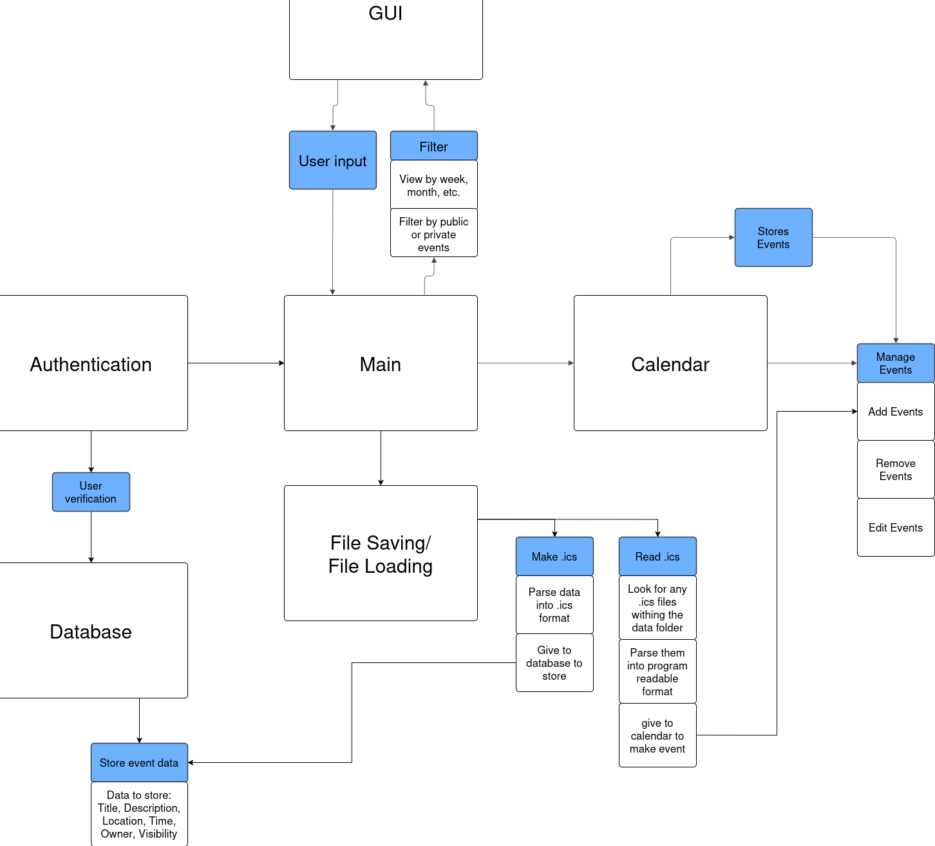

* Technology stack and design

The code, front and back end, will be written in python. Github will be utilized as a version control system. Python is an easy language to write in, and will save time on creating, tweaking, and debugging code. Github is a highly accessible and secure place to save our code, ensuring we don't lose it.

* Data design

The main entity will be an event placed somewhere on the calendar. It will have to interact both with the front end and back end. On the front side, it will have to be displayed clearly on the date it corresponds with. On the back end, it’ll need to be connected with other features like event editing, public/private options.

* FlowChart

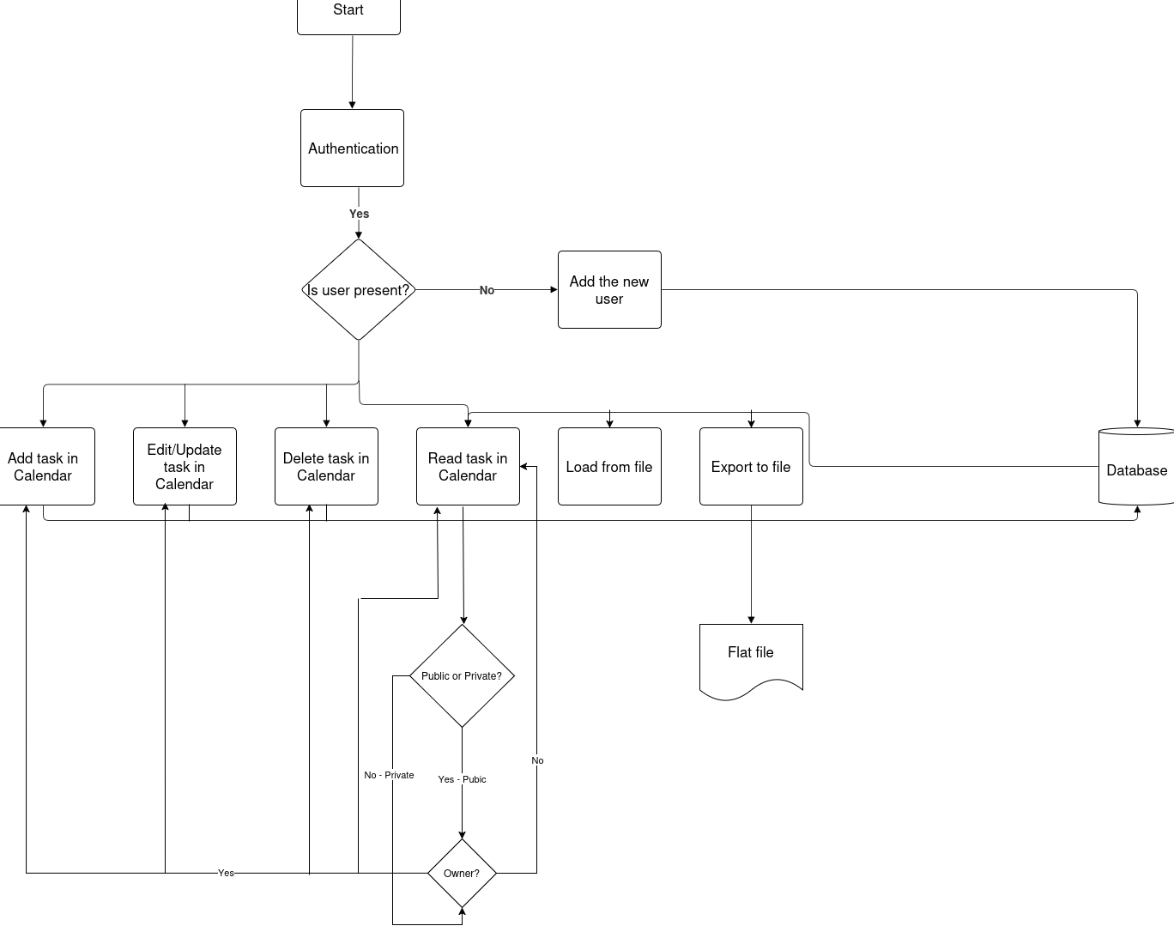

* User interface sketches

Main screen



* Risk analysis

I think our biggest issue will be with communication as nearly nobody has participated in a large scale group project prior to this one. Most of the developers are used to working solo, and not with a collaborative group. This can be mitigated by keeping a constant log of everything being done, and making sure everybody knows about decisions that will affect the group.

Secondary to communication flaws, creative disputes could potentially be a large flaw. Since we have a larger group, we have a lot of different ideas as to what route the code should take. This can lead to disagreement, and slow down the group's ability to work. To solve this we can use a case by case basis. There are several methods we can entail, such as a vote based system where the majority (4 members) have the final say. We can also employ a middle ground system, where we try to find a way to accommodate both sides of the dispute.